Money Control Fixed Depost Calculator Automation

1. **PROBLEM STATEMENT**

Need to automate the following activities using Selenium + Java

1. **BUSINESS REQUIREMENTS:**

Navigate to <https://www.moneycontrol.com/>

1. Navigate to “Fixed Deposit Interest Calculator” sub-menu from “Personal Finance” Menu.
2. Enter Investment amount.
3. Enter Investment period.
4. Enter rate of return.
5. Select interest frequency.
6. Fetch total payment.

For all the above activities to accomplish, there are template methods in Activites Class. These methods need to take use of helper methods available in SubActivites class. Those are also templated.

Helper methods to be implemented are as follows:

* + 1. Find an element using xpath. Add appropriate locators in locator class and use them here

**Expectations:**

1. Learners should write automation script using Java and selenium to automate all the steps in the above question. In other words, automation script should perform all mentioned steps.
2. Learners should not use any tools to create the xpath. They should develop the xpath/cssselector on their own.
3. **IMPLEMENTATION/FUNCTIONAL REQUIREMENTS**
   1. **CODE QUALITY/OPTIMIZATIONS**
      1. Associates should have written clean code that is readable.
      2. Associates need to follow SOLID programming principles.

# 4 EXECUTION STEPS TO FOLLOW

1. **You are mandatory required to run test cases for applications before final submission. Without which project evaluation will not happen**
2. **You can run the Junit test cases using Eclipse menu options**
3. **Before final submission, you are also required to push your code to GIT. Following are the steps to follow:**

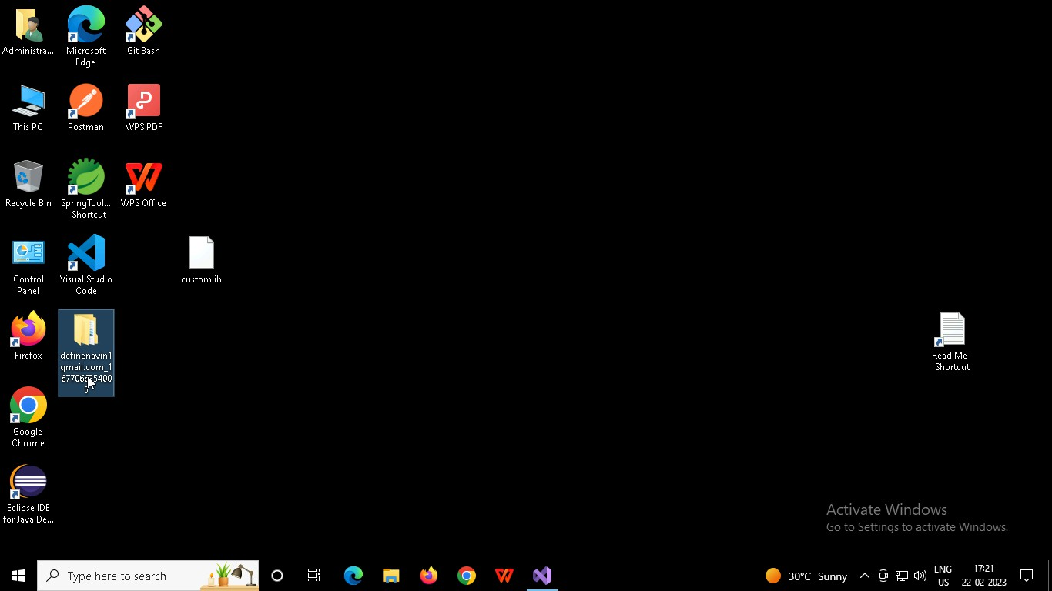

Right click in folder and open Git Bash

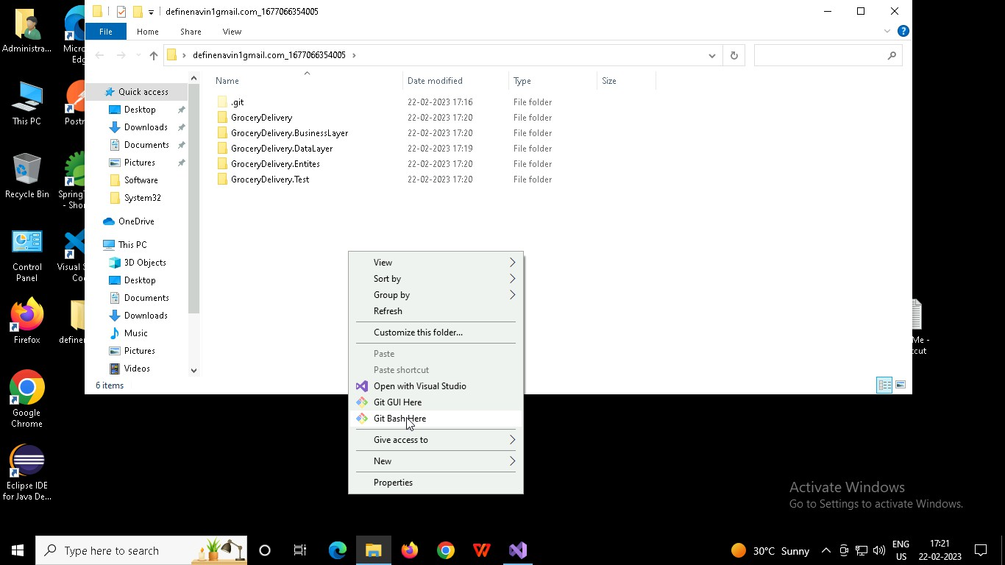

In Git bash terminal, run following commands

* 1. git status
  2. git add .
  3. git commit -m “First commit”

(You can provide any message every time you commit)

* 1. git push

